Safety and Effectiveness of Single Portal Supra-Retinacular Endoscopic Carpal Tunnel Release in Treatment of Idiopathic Carpal Tunnel Syndrome.

Ashraf El-Desouky,¹ MD, Shawky A. Elmeleigy², MD, Hamada M. Khater³, MD, Mohammed Lotfy ⁴MD, Mohammed Mourad,⁵ MD,
Neurosurgery Department, Benha University^{1,2,5} Neurosurgery Department, Cairo University ⁴ ,Radiology Department, Benha University³
ABSTRACT
Background: The most common entrapment neuropathy of the upper limb is Carpal tunnel syndrome (CTS). Endoscopic carpal tunnel release (ECTR) is superior to open CTR. Fewer techniques exist using instruments to guide endoscope from outside carpal tunnel and published reports regarding that are quite rare.
This study is to evaluate safety and effectiveness of single portal supra-retinacular ECTR in treatment of idiopathic CTS.
Methods: This study included consecutive patients with idiopathic CTS underwent single portal supra-retinacular ECTR from December 2019 to June 2020 with post-operative follow-up period of 6 months. The Boston Carpal Tunnel Syndrome Questionnaire (BCTSQ) results at 1-, 3-, and 6-months post-operative compared to pre-operative scores as main clinical evaluation. In addition to scar tenderness scale, recurrence of symptoms and post-operative complications.
Results: 45 patients aged from 29 to 63 years were included (a total of 51 procedures). There was a significant improvement in Functional Status Score (FSS) and Symptom Severity Score (SSS) post-operative compared to pre-operative scores (P=0.0001). And also, a significant progressive reduction in mean FSS/SSS recorded 1, 3 and 6-months post-operative than pre-operative. Pillar pain recorded in 7 hands and disappeared in 3 patients during follow up. No wound infection. Recurrent symptoms were not detected at end of follow-up.
Conclusion: This technique is safe and effective alternative to Infra-Retinacular ECTR in treatment of idiopathic CTS. Also, it is simple, less expensive technique enabling complete division of transverse carpal ligament and avoiding higher risk for transient median nerve dysfunction.
Key words: Carpal tunnel syndrome, Endoscopic carpal tunnel release, Boston carpal tunnel syndrome questionnaire
Correspondence to Ashraf EL-Desouky. Department of Neurosurgery, Benha University; Egypt Tel.: +201112421973 Email: ashrafeldesouky73@gmail.com

Introduction:
The most common entrapment neuropathy of the upper limb is Carpal tunnel syndrome (CTS). [1] In the presence of severe and long-standing symptoms with resistance to conservative treatment, surgical release is preferred.[ 2] The current clinical practice guideline of American Academy of Orthopedic Surgery (AAOS) recommends "complete division of the flexor retinaculum" for surgical treatment of CTS, however it does not recommend a specific technique for Carpal tunnel release (CTR). [3 ] The endoscopic CTR technique is superior to open CTR in terms of recovery time, return of hand strength, functional outcome, patient satisfaction, and shorter absenteeism from work,[ 4,5] however due to inserting instruments into the stenosed carpal tunnel it is also associated with a higher risk for transient median nerve dysfunction.[6,7] Most endoscopic techniques using an infra-retinacular or trans-carpal tunnel approach. The most commonly used ECTR techniques are those of Chow [8] and Agee et al. [9], and both require insertion of endoscopes with trocars into the carpal tunnel to cut the transverse carpal ligament (TCL) from its undersurface. [10]. Few techniques exist using instruments to guide the endoscope from outside the carpal tunnel. [11] Ip et al., [12] and Ecker et al., [13] presented a supra-retinacular ECTR technique, enabling a view from above, where the endoscope is inserted superficial to flexor retinaculum (F.R.). This technique improved visualization of entire TCL and avoided disturbing median nerve before flexor retinaculum dissection. Published reports of such an approach are, however, quite rare. [11]
The aim of this study is to evaluate the safety and effectiveness of this single portal supra-retinacular ECTR technique using nasal speculum to guide the endoscope from outside the carpal tunnel in treatment of idiopathic CTS.
Methods:
This study conducted from December 2019 to June 2020. It included 61 hands in 54 consecutive patients diagnosed with idiopathic CTS and operated upon using single portal supra-retinacular ECTR with post-operative follow-up period of 6 months. All included patients were not responding to conservative treatment. The criteria for diagnosis of CTS include numbness and tingling in the median nerve distribution, nocturnal numbness, weakness and/or atrophy of the thenar muscles.[14] Then the following provocative tests were used: wrist flexion test (Phalen’s test), carpal compression test (Durkan test), Tinel’s percussion test to help the diagnosis of CTS.[15] For all patients, the diagnosis was confirmed by electromyography (EMG) with evidence of median nerve compression below the elbow. The electrophysiological study performed with Neuropack four EMG/EP machine (Nihon Kohden, Japan) and all patients evaluated using the same protocol. According to normative data in our laboratory, the patient has CTS if the following were present: distal motor latency prolonged (> 4.5 m. sec) and compound motor unit action potential (CMAP) amplitude decreased (< 4 μ. V); antidromic wrist-to- digit sensory latency exceeded 3.5 m. sec, sensory nerve action potential (SNAP) amplitude was < 20 μ. V, and when antidromic wrist-to-digit sensory nerve conduction velocity (SCV) was less than 50 m/sec.
According to American Association of Electrodiagnostic Medicine (AAEM) guidelines electrophysiological findings were graded into the following categories:
Mild CTS: Prolonged distal sensory latency with decreased sensory amplitude., moderate CTS: Abnormal median sensory latencies with prolongation of distal motor latency., Severe CTS: Prolonged motor and sensory distal latency, either with a low or absent SNAP or CMAP., Very severe CTS: Absent thenar motor or sensory response, with lumbrical response either present or absent.[16]
Preoperative high-resolution ultrasound also was done using a high-performance LOGIQ P7, a device that offers a high-resolution color monitor providing images without any flicker (General Electric, USA), to help diagnosis and to do preprocedural planning for all patients .The cross-sectional area (CSA) of the median nerve was measured at the entrance of the carpal tunnel, The abnormal median nerve CSA at scaphoid-pisiform level can range 10 – > 13 mm² (mild expansion value), 13–15 mm² (moderate expansion value), and < 15 mm² (severe expansion value).[17,18]
For preprocedural planning, patients scanned to ensure visualization of major anatomic structures to have accurate surface landmarks, and to exclude possible anatomic variations. The scan included the following: Median nerve; palmar cutaneous branch; thenar motor branch, bony boundaries of the carpal tunnel, ulnar vessels; transverse safe zone (TSZ) where it lies between medial aspect of median nerve and lateral aspect of ulnar vessels or hook of hamate, whichever lies more lateral to show that the anatomy is normal along the anticipated line of TCL transection; distal TCL; and superficial palmar arterial arch. [19] (see Figure 1)
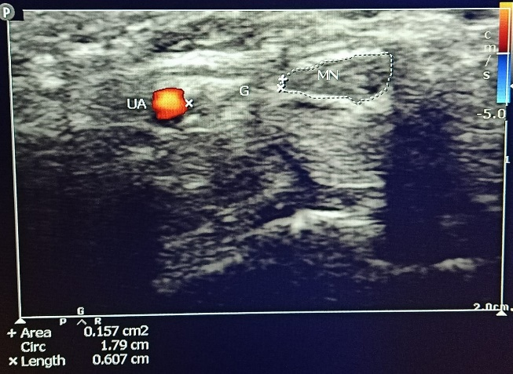
Figure 1: US of the wrist of a female patient ,43 years old showing median nerve (MN), ulnar artery (UA), the flexor retinaculum covers these structures and long flexor tendons beneath. Transverse safe zone (G)= 6 mm with expanded edematous flattened MN with cross section area =15.7mm² mounting to severe CTS

The Boston Carpal Tunnel Syndrome Questionnaire (BCTSQ) [20] results at 1-, 3-, and 6-months post-op. collected and compared to pre-op scores as the main clinical evaluation. The BCTSQ is a 19-question, patient questionnaire, (we translated to the patient into Arabic) that evaluates severity of symptoms (SSS) (11 questions) and functional status (FSS) (8 questions) using a scale of 5-point (1 = best score and 5 = worst score). In addition to using the scar tenderness 5-point Likert scale (0 = none, 1 = mild, 2 = moderate, 3 = severe, 4 = very severe) to evaluate scar tenderness, the pillar pain evaluation by visual analogue scale (VAS), (0 = no pain, 10 = worst pain).[21] Recurrence of symptoms, % of patient satisfaction and post-operative complications were all recorded.
Exclusion criteria include the following: patients with DM, cervical radiculopathies, patients with history of wrist trauma, recurrent CTS, and pregnant patients. We excluded also illiterate patients for better evaluation by BCTSQ.
Surgical technique:
The operation was performed under local infiltration anesthesia without tourniquet control, using 5-10 cc of 2% xylocaine and then infiltration of 5-10 cc of 1/ 200000 parts epinephrine to minimize intraoperative bleeding. A transverse skin incision was made, approximately 1-1.5 cm located at the level of the proximal palmar wrist flexion crease just medial to palmaris longus tendon then the exposed antebrachial fascia opened carefully to expose the median nerve underneath. Using blunt dissecting scissor, the antebrachial fascia and distal part of deep fascia of the forearm dissected from the median nerve underneath and from overlying skin, and median nerve released under direct visualization. Then to free the median nerve in the carpal tunnel from undersurface of TCL so not to be injured during the release, we used Mc Donald dissector through the opening in. antebrachial fascia. A tunnel about 1.5-2 cm wide was created between superficial subcutaneous tissue and flexor retinaculum using blunt dissecting scissor, starting at the transverse skin incision and ending proximal to Kaplan’s cardinal line, with the long axis between the middle and ring fingers in its center.
The nasal speculum then inserted to the subcutaneous space and opened gently (transversely) to keep the tunnel open. Due to the speculum instrument's structure the 2 beaks separate the surrounding structures completely and then the endoscope (straight forward telescope, 4 mm in diameter, 18 cm in length, 0 Degree- Karl Storz- endoscope, Tuttlingen, Germany,) moved in and out to explore the supra-retinacular space and so we had endoscopic view of the flexor retinaculum from above which allow visualization of the TCL. At the transverse skin incision, blunt scissor was then used to divide the proximal part of the TCL and visualize the median nerve underneath and then TCL divided in the direction of the radial border of the ring finger under endoscopic vision in series of small sequential cuts, until the entire TCL was completely released which was confirmed by clear visualization of mid-palmar pad of fat which covers the median nerve after distal border of TCL. In order to restrain subcutaneous fat which may occlude the light of the endoscope, we can reapply the nasal speculum vertically (upside dawn) so one peak is superficial to TCL lifting the fat and the other peak is under the remaining distal border of TCL and then the endoscope and blunt scissor can pass between the 2 peaks to dissect the distal border of TCL. The wrist and proximal palm compressed for 5 minutes to achieve hemostasis. The wound was then closed with 2 mattress sutures and dressed. Elastic bandage was applied to be removed at the same night. Allowing early active motion. Non-steroidal anti-inflammatory drugs were given for 7 days for wound pain, and antibiotics prescribed for a week. The wound dressing removed after 3 days, to change dressing every 3 days and stitches were removed after 10 to 14 days. Fig 2 and 3 showing the steps of the procedure.
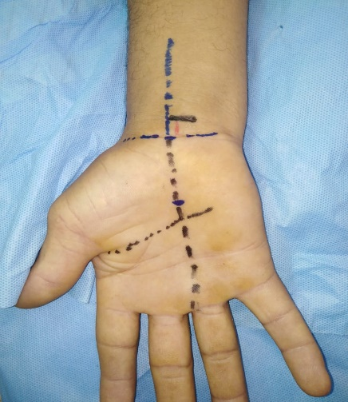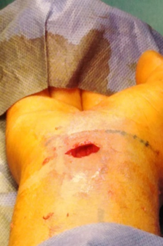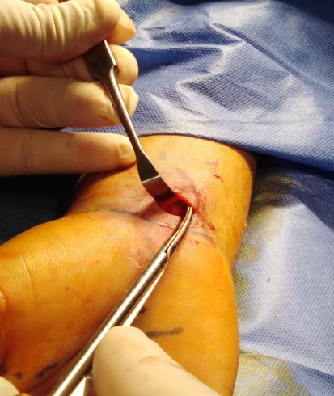
- (b) (c)
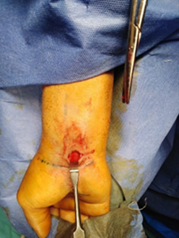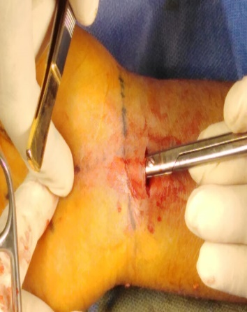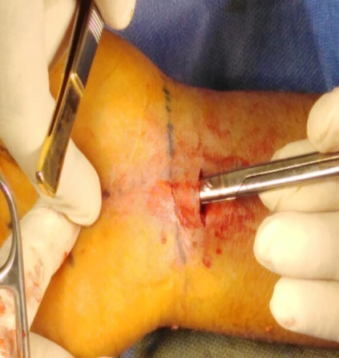
(d) (e) (f)
Fig. 2: showing; a male patient, 54 years old with right severe CT syndrome (a): anatomical surface landmarks (Kaplan’s cardinal line, tendon of palmaris longus muscle, longitudinal axis between middle and ring fingers, skin incision site medial to palmaris muscle tendon). (b) transverse skin incision 1-1.5 cm in length at proximal palmar wrist flexion crease. (c & d) dissection of antebrachial fascia and distal part of deep fascia of the forearm with exposure and release of underlying median nerve (e & f) blunt scissor dissection to create a subcutaneous tunnel 2 cm wide
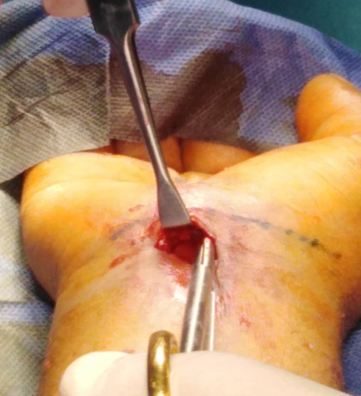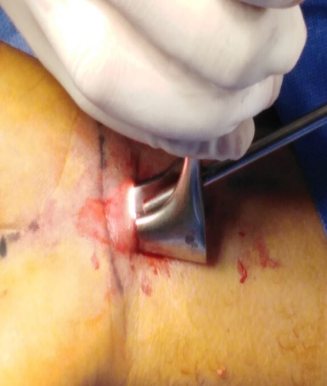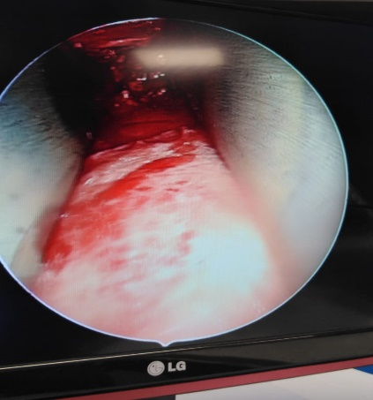
- (b) (c)
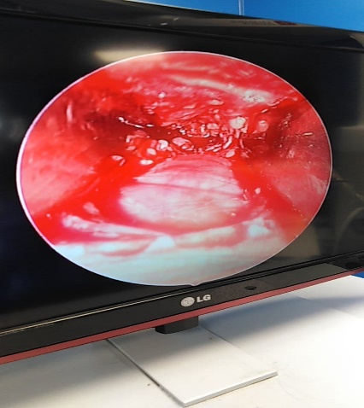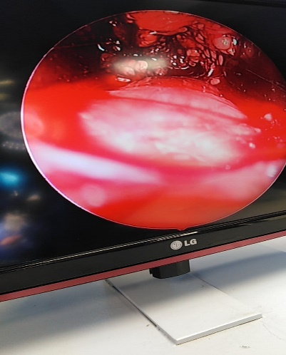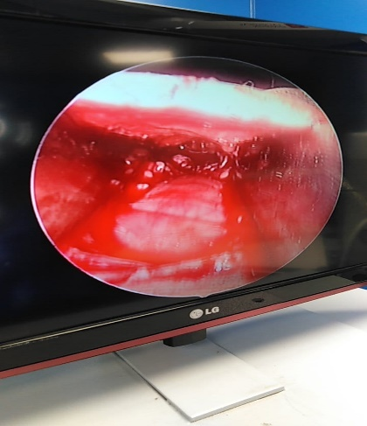
(d) (e) (f)
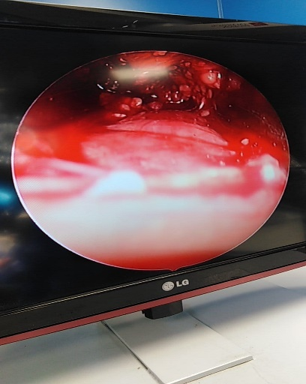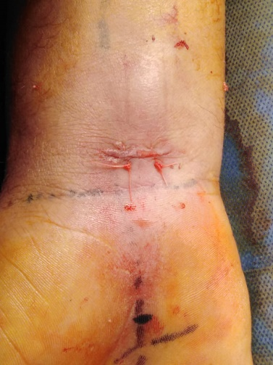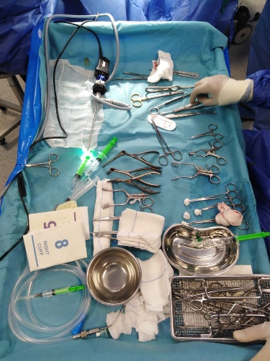
(g) (h) (i)
Fig. 3: showing; (a) dissection of proximal edge of TCL (b) apply of nasal speculum to maintain the tunnel open while passing the endoscope and blunt scissor between the 2 peeks of the speculum to divide the TCL completely to release the median nerve (c) endoscopic view of median nerve after release with speculum peeks on both sides (d, e, f, g) endoscopic view of median nerve after complete division of TCL (h) closure of wound with 2 mattress sutures (i) surgical instruments used in the procedure . This patient had near complete relieve of his symptoms after surgery
Informed consent and ethics committee approval:
This research has given approval by Research Ethics Committee (REC) of faculty of medicine. A written informed consent was obtained from each patient or the legal guardians in case the patient is unable to sign the informed consent after explaining all steps of this study to them. All procedures performed involving human participants were in accordance with the ethical standards of the institutional and/or national research committee and with the 1964 Helsinki declaration and its later amendments or comparable ethical standards.
Statistical analysis: the mean and Standard Deviation were used to describe numerical data, while the frequency and percentage were used to describe categorical data. The repeated measures ANOVA test was used detect changes in FSS/SSS obtained pre-operative, 1-month, 3-months and 6-months post-operative. Differences in paired data were examined using the paired t-test. Statistical significance was accepted at P 0.05 >. All statistical analyses were carried out using STATA/SE version 11.2 for Windows (STATA corporation, College Station, Texas).
Results:
In this study from December 2019 to June 2020, according to our inclusion criteria, 61 hands were operated upon in 54 consecutive patients, but 9 patients (10 hands) were lost to follow up. therefore, we collected and analyzed the data of 45 patients, 6 of them had both hands operated (a total of 51 procedures). 37 female patients (82.22%) and 8 male patients (17.77%) were enrolled in this study, aged from 29 to 63 years (mean 44 years). The mean duration of symptoms before surgery was 30 months (range from 6 to 72 months). 42 operations (82.35%) were performed for the right hand and 9 (17.64%) for the left hand. All patients are right-handed except 3 are left-handed.
According to EMG results, 7 hands (13.72%) had mild CTS, 15 hands (29.41%) had moderate CTS and 29 hands (56.86%) had severe CTS and when CSA of median nerve measured on ultrasound, we had 5 hands (9.8 %) with mild nerve expansion (10 - >13 mm²), 11 hands (21.56%) with moderate nerve expansion (13-15 mm²) and 35 hands (68.62%) with severe nerve expansion (<15 mm²), (mean = 15.56 mm²).
Table 1 shows; a significant improvement in FSS and SSS post-operative compared to the pre-operative scores (P=0.0001). There was a significant progressive reduction in the mean FSS/SSS recorded 1-month (2.86 (±0.41)/2.81 (±0.15), 3-months (2.18 (±0.48)/2.37 (±0.29) and 6-months (1.52 (±0.37)/1.61 (±0.16) post-operative than pre-operative (3.33 (±0.5)/3.63(±0.36). Thus, there was a significant improvement in FSS/SSS at 6-months post-operative compared to pre-operative (P<0.001).
Table1; Comparisons of BCTSQ (FSS/SSS) recorded at pre-op., 1, 3 and 6-months post-op.
Time | BCTSQ (FSS/SSS)  (No.=51)
Pre-operative | 3.33 (0.50)/3.63 (0.36)
1-month post-operative | ª2.86 (0.41)/ª2.81 (0.15)
3-months post-operative | ^{ab}2.18 (0.48)/^{ab}2.37 (0.29)
6-months post-operative | ^{abc}1.52 (0.37)/^{abc}1.61 (0.16)
F | 297.32/616.08
P-value | 0.0001/0.0001

BCTSQ [20] : Boston Carpal Tunnel Syndrome Questionnaire; FSS: Functional Status Score; SSS: Symptom Severity Score; Data were presented as mean (Standard Deviation; SD); F: repeated measures ANOVA test; a: significant difference compared to pre-operative scores (P<0.001); b: significant difference compared to 1-month post-operative scores (P<0.001); c: significant difference compared to 3-months post-operative scores (P<0.001); the paired t-test was used to detect difference in paired data.

A total of 45 hands (88.23%) had excellent relief of symptoms (90%-to-complete improvement), three hands (5.88%) had good relief of symptoms (70% -to- 90% improvement), two hands (3.92%) had fair relief of symptoms (50%-to-70% improvement), and one hand (1.96%) had only minimal improvement in the symptoms (Less than 50%- improvement).

Table 2; Relief of symptoms as reported by patients at 6 months post-operative
Degree of relief | No. | % | % Of improvement of symptoms
Excellent relief | 45 | 88.23 | (90%-to-complete improvement)
Good relief | 3 | 5.88% | (70% -to- 90% improvement)
Fair relief | 2 | 3.92% | (50%-to-70% improvement)
Minimal relief | 1 | 1.96% | (Less than 50%- improvement)

Mild to moderate scar tenderness seen in 6 hands (11.76 %.) in the 1-month post op, which disappeared completely at 3 months post op. Pillar pain recorded in 7 hands (13.72%); which disappeared in 3 hands during 6 months of follow up while the remaining 4 hands (7.8%) showed satisfactory improvement (with VAS score 2-3) but not complete recovery. The cosmetic results were rated by the patients as excellent in 47 hands and good in 4 hands. We had no wound infection. No patient reported worsening of symptoms and recurrent symptoms were not detected at end of follow-up.
Discussion:
Surgical treatment of the carpal tunnel was initially represented by Galloway in 1924. [14] and later popularized by Phalen.[22] Multiple surgical techniques are outlined in literature; none has vital superiority over the others. All of those are sufficient to release the median nerve.[23] In spite of the high degree of efficacy and safety already incontestable in current CTR techniques, new technologies and information still modification follow. These embrace new less-invasive surgical techniques, and new studies of outcome and complications.[24]
The long-term outcomes of OCTR and ECTR are both excellent, however the trend in all branches of surgery is towards a minimally invasive approach, thus methods such as ECTR are gaining popularity.[25] Since the first description of ECTR in 1987 by Okutsu, many endoscopic techniques have been developed.[12] These techniques employ an infra-retinacular or trans-carpal tunnel approach. The most common infra-retinacular ECTR techniques are those of Chow [8] and Agee et al.,[9] and both require insertion of endoscopes equipped with trocars into the carpal tunnel to cut TCL from its undersurface[10] however due to inserting instruments into the stenosed carpal tunnel it is also associated with a higher risk for transient median nerve dysfunction.[6,7] ECTR is not without risk, where injury of the superficial palmar arch , median or ulnar nerve as well as incomplete release of the carpal tunnel have been well documented.[26,27] ECTR is a demanding technique which is prone to technical errors, and some authors had questioned whether its benefits outweighed the potential risks.[28] Few techniques exist that rely on instruments that guide the endoscope from outside the carpal tunnel, enabling a view from above.[11] In the technique we present here for CTR, using the nasal speculum to guide the endoscope superficial to flexor retinaculum allows visualization of entire TCL from above and circumvents any unnecessary compression of median nerve in already constricted tunnel. Published reports of such an approach are, however, quite rare.[11] In our study, we used the BCTSQ [20], to assess the disability associated with CTS as it is the most popular outcome measure used in the literature. The results at 1-, 3-, and 6- months post-op. collected and compared to pre-op scores as the main clinical evaluation. The statistical analysis showed a significant improvement in FSS and SSS post-op. compared to the pre-op. scores (P=0.0001). There was a significant progressive reduction in the mean FSS/SSS recorded 1-month (2.86 (±0.41)/2.81 (±0.15), 3-months (2.18 (±0.48)/2.37 (±0.29) and 6-months (1.52 (±0.37)/1.61 (±0.16) post-op. than pre-op. (3.33 (±0.5)/3.63(±0.36). Thus, there was a significant improvement in FSS/SSS at 6-months post-op. compared to pre-op. (P<0.001).
We compared our results to other studies used open, mini-open and endoscopic techniques and we found that, in the current study pre-op. F./S. (3.33 /3.63) reduced to post-op. F./S. (1.52 /1.61) at 6 months follow up. Heybeli et al., [29] used Open technique (n=44). pre-op. F./S. (3.3 / 3.4) reduced to post-op. F./S. (1.40 / 1.30) at 6 months follow up. Atroshi et al.,[30] used Open technique (n=63) pre-op. F./S. (2.37 / 3.08) reduced to post-op. F./S. (1.19 / 1.38) at 12 months post-op. Asan et al.,[23] used mini-open (n=131) pre-op. F./S. (3.25 / 3.27) reduced to post-op. F./S. (1.48 / 1.47) at 12 months post-op. Atroshi et al.,[30] used endoscopic technique (n=63) pre-op. F./S. (2.37 / 3.15) reduced to post-op. F./S. (1.25 / 1.40) at 12 months post-op. Trung et al.,[18] used ECTR technique in a study conducted on 150 hands in 118 patients, The BQ score reduced from initial 3.43 to 1.30 at 6-months follow-up and they reported that this difference is statistically significant (p < 0.05) and their results are similar to those in [31,32,33].
From this review, in spite of different techniques used and different number of patients included, the improvement we had at 6 months post-op. was similar to their results.

In our study, 48 hands (94.1%) had excellent or good relief of symptoms (70-100%), two hands (3.92%) had fair relief of symptoms (50-70%), and one hand (1.96%) had only minimal improvement in symptoms (< 50%). A-short term study by Malhotra et al., compared results of ECTR with open CTR in patients with idiopathic CTS and showed at 6 months post-op. remission of symptoms in ECTR ( group of 30 patients) where 29 patients (96.66% ) had 75-100% improvement , and one patient (3.3%) was < 50% improvement and these results were similar to ours , while in open CTR (group of 31 patients ) our results were relatively better where in the study by Malhotra et al. 28 patients (90.32% ) had 75%-100% improvement and two patients (6.45%) had < 50% improvement .[34] While most patients have symptom improvement after surgical treatment, some patients still cannot be satisfied with the outcome, because CTS doesn’t only affect the function but also the psychosocial aspect. [35]
In our study we had mild to moderate scar tenderness in 6 hands (11.76 %.) in the 1st month post op., this tenderness disappeared completely at 3 months post op. In a study by Malhotra et al., at six months after surgery scar tenderness observed in nine hands (29.03%) of open CTR group while no scar pain in ECTR group.[34] So, our results regarding scar tenderness is in accordance to ECTR group of the study by Malhotra et al and better than the results of their OCTR group.
Pillar pain, is reported as the most common complication after CTR, whereas, the incidence was estimated between 6% and 36% regardless of the surgical technique.[36] in our study pillar pain recorded in 7 hands (13.72%); which disappeared in 3 patients during 6 months of follow up while the remaining 4 patients (7.84%) showed satisfactory improvement (with VAS score 2-4) but not complete recovery. With OCTR, the incidence of pillar pain was 23.1% while in the mini-incision technique, the incidence of pillar pain was only 18.4%. In a study by Castillo et al., they reported three patient of mini -open technique group complained of pillar pain.(23.1%) at 6 months follow up .[21] Accordingly, we found our results are adequately encouraging and we think this may be attributed to our technique which preserves the soft tissues and small subcutaneous nerve branches between the thenar and hypothenar eminences.
Our average time to return to daily activity was 18 days which was in accordance to that reported by Malhotra R. et al.,[34] ( their average time to return to daily activities was 16 days) for ECTR group of patients and was found relatively shorter than their OCTR group of patients ( average 20 days).
In our study we had no wound infection, while in open CTR the infection rate reported was 0.32%.[37] and in a study by Nazerani et al., using ECTR , they reported wound infection rate of 0.56% .[38] Although we didn’t detect recurrent symptoms at the end of 6 months follow-up, longer follow up still recommended.
The limitations of the present study included being non-randomized so it may have some bias in patient selection, also, the short-term follow-up so for assessment of recurrence rate we recommend longer follow up.
Conclusion: The Supra-Retinacular ECTR technique is a safe and effective alternative to Infra-Retinacular ECTR in treatment of idiopathic CTS, with comparable low incidence of scar tenderness and pillar pain, significant post-op. improvement of symptoms severity and functional outcome. Also, it is simple, less expensive technique enabling complete division of TCL and avoiding higher risk for transient median nerve dysfunction.
List of Abbreviation:
CTS: Carpal tunnel syndrome
ECTR: Endoscopic carpal tunnel release
BCTSQ: The Boston Carpal Tunnel Syndrome Questionnaire
FSS functional status score:
SSS: symptoms severity score
TCL: transverse carpal ligament:
M.N.: Median nerve
AAOS: Academy of Orthopedic Surgery
F.R.: flexor retinaculum
EMG: electromyography:
CMAP: Compound motor unit action potential
SNAP: sensory nerve action potential
SCV: sensory nerve conduction velocity
AAEM: American Association of Electrodiagnostic Medicine
CSA: cross-sectional area
TSZ: transverse safe zone
VAS: visual analogue scale

Declaration of interest and Funding information.: The authors report no conflicts of interest.
Authors’ contributions: All authors have participated in the research and article preparation and all of them read and approved the final version of the study
Authorship: All authors have made contributions to the following: (1) the conception and design of the study, acquisition of data, analysis and interpretation of data, (2) drafting the article and revising it for important intellectual content, (3) final approval of the version to be submitted.
Acknowledgment:
We would like to thank Dr. Hanaa El-Sayed Bayomy, Associate Professor of Public Health and Community Medicine, Benha Faculty of Medicine, Benha University for great effort in accomplishing the statistical analysis of this study
www.bu.edu.eg & www.fac.bu.edu.eg

References:
- Green DP, Pederson WC, Hotchkiss RN, Wolfe SW. Greens Operative Hand Surgery. 5th ed. Philadelphia: Elsevier Churchill Livingstone; 2005. pp. 1009–18.
- Cranford CS, Ho JY, Kalainov DM, Hartigan B J. Carpal tunnel syndrome. J Am Acad Orthop Surg 2007; 15 (9):537-48.
- Keith MW, Masear V, Armadio PC, Andary M , Barth RW, Graham B et al. Treatment of carpal tunnel syndrome. J Am Acad Orthop Surg. 2009; 17(6):397–405.
- Heidarian A, Abbasi H, Hasanzadeh H M, Hajialibeyg A, Motamedi SM, Seifirad S. Comparison of Knife light surgery versus conventional open surgery in the treatment of carpal tunnel syndrome. Iran Red Crescent Med J. 2013;15(5):385-388.
- Vasiliadis HS, Nikolakopoulou A, Shrier I, Lunn MP, Brassington R, Salanti G et al. Endoscopic and open release similarly safe for the treatment of carpal tunnel syndrome: a systematic review and meta-analysis. PLoS One. 2015;10(12): e 0143683.
- Ejiri S, Kikuchi S, Maruya M, Sekiguchi Y, Kawakami R, Konno S. Short-term results of endoscopic (Okutsu method) versus palmar incision open carpal tunnel release: a prospective randomized controlled trial. Fukushima J Med Sci. 2012;58(1):49-59.
- Goss BC, Agee JM. Dynamics of intracarpal tunnel pressure in patients with carpal tunnel syndrome. J Hand Surg Am. 2010;35(2):197-206.
- Chow JC. Endoscopic release of the carpal ligament: a new technique for carpal tunnel syndrome. Arthroscopy 1989;5(1):19-24.
- Agee JM, McCarroll HR, North ER. Endoscopic carpal tunnel release using the single proximal incision technique. Hand Clin. 1994;10(4):647-659.
- Palmer DH, Paulson JC, Lane-Larsen CL, Peulen VK, Olson JD. Endoscopic carpal tunnel release: a comparison of two techniques with open release. Arthroscopy. 1993; 9(5):498–508.
- Bartłomiej HN, Krzesniak N, and Nowak M :Superficial plane endoscopy for carpal tunnel release. Wideochir Inne Tech Maloinwazyjne. 2014;9(2):262-6.
- Ip WY, Sweed TA, Fung KK, Tipoe GL, Pun TS. A new technique of single portal endoscopic carpal tunnel release. Tech Hand Up Extrem Surg. 2012;16(1):27-29.
- Ecker J, Perera N, Ebert J. Supraretinacular endoscopic carpal tunnel release: surgical technique with prospective case series. J Hand Surg Eur 2015;40(2):193-198.
- B G, Regehr G, Naglie G, Wright JG. Development and validation of diagnostic criteria for carpal tunnel syndrome. J Hand Surg [Am]. 2006;31(6):919–24.
- Bickley LS, Szilagyi PG, Bates B. guide to physical examination and history taking. 9th ed. Netherlands: Lippincott Williams & Wilkins. p. 2007–992.
- Jablecki CK, Andary MT, So YT, Wilkins DE, Williams FH. Literature review of the usefulness of nerve conduction studies and electromyography for the evaluation of patients with carpal tunnel syndrome. AAEM Quality Assurance Committee. Muscle Nerve 1993; 16:1392-414.
- McDonagh C, Alexander M, Kane D. The role of ultrasound in the diagnosis and management of carpal tunnel syndrome: a new paradigm. Rheumatology (Oxford). 2015;54(1):9–19
- Trung DT, Ngoc TM, Gia DH, Ngoc SD, Manh SL, Xuan TD et al., Endoscopic carpal tunnel release surgery: a case study in Vietnam. Journal of Orthopaedic Surgery and Research 2019; 14(1):149.
- Rojo-Manaute JM, Capa-Grasa A, Chana-Rodríguez F, Perez-Mañanes R , Sanz-Ruiz P , Rodriguez-Maruri G et al., Ultra-Minimally Invasive Ultrasound-Guided Carpal Tunnel Release: A Randomized Clinical Trial. J Ultrasound Med 2016 ;35(6):1149-57.
- Levine DW, Simmons BP, Koris MJ, Daltroy LH, Hohl GG, Fossel AH, et al. A self-administered questionnaire for the assessment of severity of symptoms and functional status in carpal tunnel syndrome. J Bone Joint Surg Am 1993; 75(11):1585–1592
- Castillo TN and Yao j. Prospective randomized comparison of single-incision and two-incision carpal tunnel release outcomes. Hand (N Y) 2014; 9(1): 36–42.
- Phalen GS. The carpal-tunnel syndrome: seventeen years’ experience in diagnosis and treatment of six hundred fifty-four hands. J Bone Jt Surg Am. 1966; 48(2):211–228.
- Asan Z. Modified mini-incision surgery for carpal tunnel syndrome: Results of 131 interventions. J Clin Anal Med 2018;9(5): 381-5
- Jacob E T, Asif M I. Carpal Tunnel Syndrome Surgery: What You Should Know. Plastic and Reconstructive Surgery - Global Open 2020; 8 (3): e2692.
- Sabesan VJ, Pedrotty D, Urbaniak JR, Aldridge JM, 3rd. An evidence-based review of a single surgeon's experience with endoscopic carpal tunnel release. J Surg Orthop Adv. 2012;21(3):117–21.
- Erhard L, Ozalp T, Citron N, Foucher G. Carpal tunnel release by the Agee endoscopic technique: results at 4-year follow-up. J Hand Surg. (Br) 1999;24(5):583-5.
- Mackenzie DJ, Hainer R, Wheatley MJ. Early recovery after endoscopic vs short-incision open carpal tunnel release. Ann Plast Surg. 2000; 44(6):601-4.
- Berger PA. Endoscopic carpal tunnel release: a current perspective. Hand Clin. 1994; 10(4):625-36.
- Heybeli N, Kutluhan S, Demirci S, Kerman M, Mumcu EF. Assessment of outcome of carpal tunnel syndrome: a comparison of electrophysiological findings and a self-administered Boston questionnaire. J Hand Surg Br. 2002; 27(3): 259- 64.
- Atroshi I, Hofer M, Larsson GU, Ornstein E, Johnsson R, Ranstam J. Single-incision compared with 2-portal endoscopic carpal tunnel release: a 5-year follow-up of a randomized controlled trial. J Hand Surg [Am] 2009;34(2):266–272.
- Calotta NA, Lopez J, Deune EG. Improved surgical outcomes with endoscopic carpal tunnel release in patients with severe median neuropathy. Hand (N Y). 2017; 12(3):252–257.
- Gumustas SA, Ekmekci B, Tosun HB. Similar effectiveness of the open versus endoscopic technique for carpal tunnel syndrome: a prospective randomized trial. Eur J Orthop Surg. Traumatol. 2015; 25:1253–60
- Sayegh ET, Strauch RJ. Open versus endoscopic carpal tunnel release: a meta-analysis of randomized controlled trials. Clin Orthop Relat Res. 2015; 473(3):1120–32.
- Malhotra R, Kiran EK, Dua A, MallinathS.G, and Bhan S. Endoscopic versus open carpal tunnel release: A short-term comparative study. Indian J Orthop.2007; 41(1): 57–61.
- Yu Chen A.C., Meng-Huang WU, M.H, Cheng C.Y and Chan Y.S.; Outcomes and Satisfaction with Endoscopic Carpal Tunnel Releases and the Predictors - A Retrospective Cohort Study. Open Orthopaedics Journal 2016; 10: 757-764.
- Huisstede BM, van den B J, Randsdorp MS, Geelen SJ, Koes BW. Effectiveness of surgical and postsurgical interventions for carpal tunnel syndrome-A systematic review. Archives of physical medicine and rehabilitation. 2018; 99(8):1660–80.
- Werner BC, Teran VA, Deal N. Patient-Related Risk Factors for Infection Following Open Carpal Tunnel Release: An Analysis of Over 450,000 Medicare Patients. The journal of hand surgery 2018; 43 (3): 214-219.
- Nazerani S, Motamedi MH , Nazerani T , Saraii A, Keramati MR. Endoscopic Carpal Tunnel Release: A 5-Year Experience. Trauma Mon 2014; 19(4): e18058.

